Practical 3
Question:
Write a C program to demonstrate the parent–child relationship between processes created using fork(). Display the PID and PPID of each process, introduce a delay in the child using sleep(), and use wait() in the parent so that it resumes only after the child has terminated.
Code:
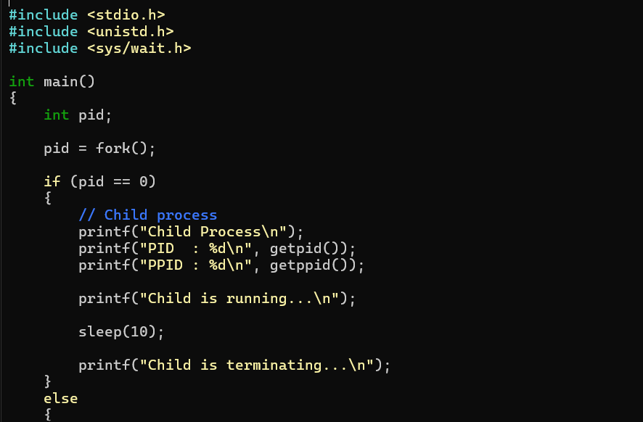
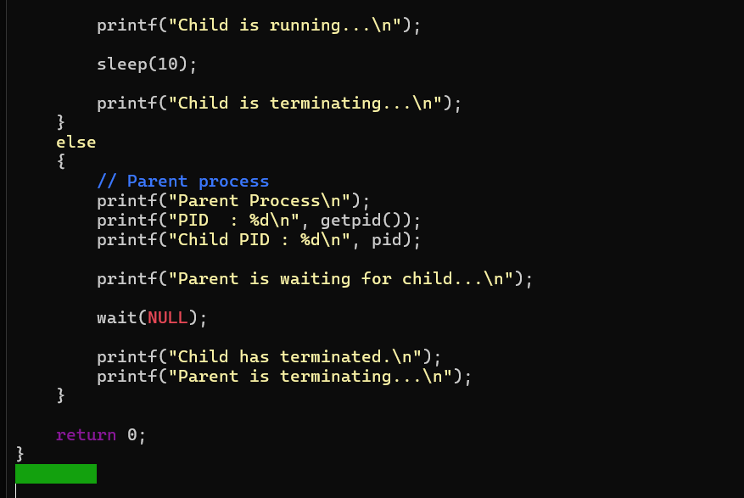
Output:
